# Reasons for popularity of Linux OS

1)Price (It is free and open source)

2)Security (We do not need any anti virus for linux OS)

3)Stability (Not prone to crashes)

4)Support (It has a very strong community support)

Components of Linux OS

Bootloader : When we power on a computer,we need a piece of software which will guide the OS the steps it will take to power on a computer.

Kernel : heart of OS

INIT process : The first process that starts inside the computer.PID = 1 for this process.

Background Services : INIT process will start several child process and these are known as deamons example login , ssh.

Shell : We need something to interact with OS.

Example : Bash (Bourne Again Shell) is the free and enhanced version of the Bourne shell distributed with Linux.

Graphical Environment : provides UI to interact with linux (Xserver) Gnome, KDE

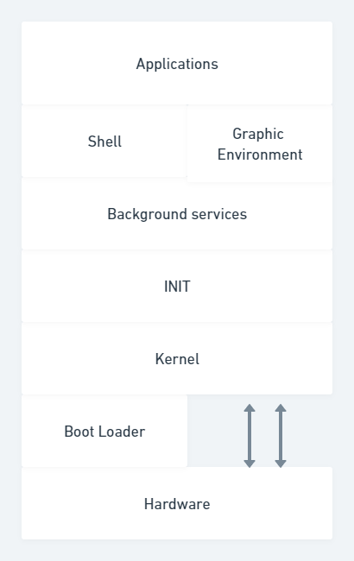

# Linux Processes

Process: Program in execution. Two kinds of process in linux

i)Foreground process

ii)Background process

## Foreground process

A process which is interactive and redirects its output on the screen. This needs a terminal for its execution. It may or may not take the input from the user. If it has to take the input from the user, it can take it from the terminal or UI and displays the output on the screen.

$ sleep 300

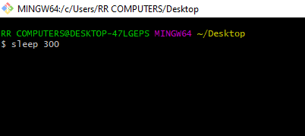

It is a foreground process as we are blocked in the terminal.

When a foreground process is running, we can not use any other process on the terminal, because we won’t get any prompt on the terminal.

## Background process

A non interactive process.

It is started by the system or the user. It does not need any input from the user. when this process is running, we can do different other operations and we are not blocked.

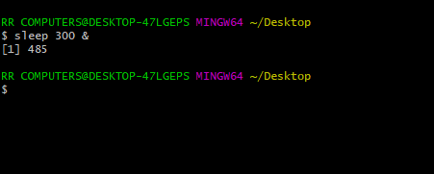

$ sleep 300 &

This does not need the terminal for execution and hence it is BG process.

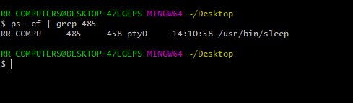

$ ps -ef | grep 485

RR COMPU 485 458 pty0 14:10:58 /usr/bin/sleep

We can see that the process is running in the BG

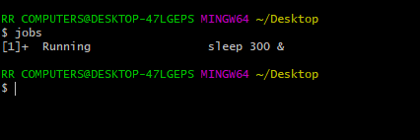

$ jobs

[1]+ Running sleep 300 &

This will display the BG running process 1 is the job id, after it is completed, it will be in done state.

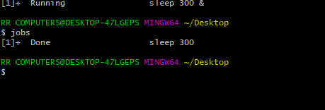

To bring the BG running process to the FG, we have the command fg.

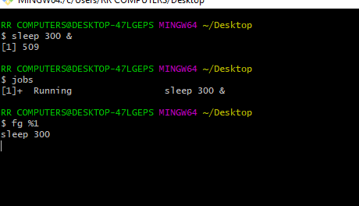

$ fg %1

sleep 300

1 is the job id.

To send the FG process to the BG. We first need to suspend the process (click ctrl+z) and then we need to run bg command.

$ sleep 300

[1]+ Stopped sleep 300

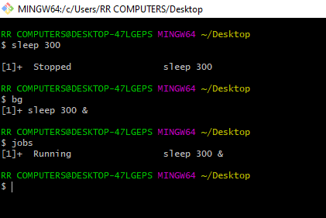

# Process Examples

To get the pid of the process which is running.

$ ps -ef | grep sleep

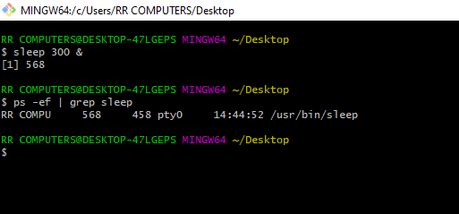

ps -ef | grep processname

Let us see the breakdown of the above

* ps - list processes
* -e - show all processes, not just those belonging to the user
* -f - show processes in full format (more detailed than default)
* command 1 | command 2 - pass output of command 1 as input to command 2
* grep find lines containing a pattern
* processname - the pattern for grep to search for in the output of ps -ef

$ echo $$

160

This will give the pid of the shell/terminal.



$ echo $PPID

159

This will give the ppid of the shell/terminal.

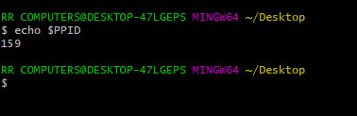

$ ps -ef

This will list down all the processes running.

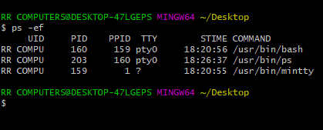

$ ps -ef | less

This will list down all the processes running in the page format.

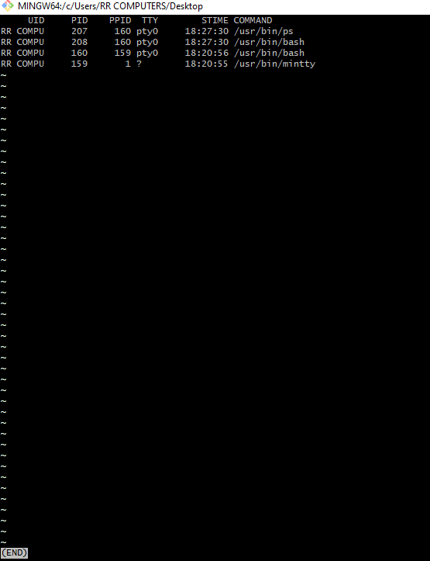

$ kill -l

This will give all the signals to be passed in the kill command.

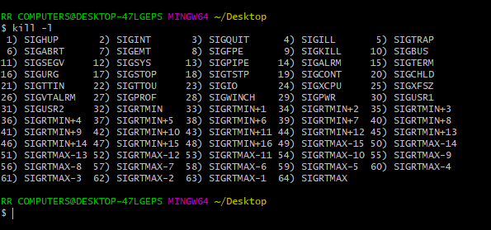

Memory usage Info

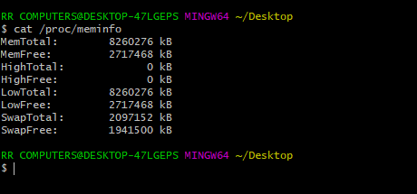

$ cat /proc/meminfo

# Linux File system

To find the memory usage in file systems we have

$ df

$ df -h

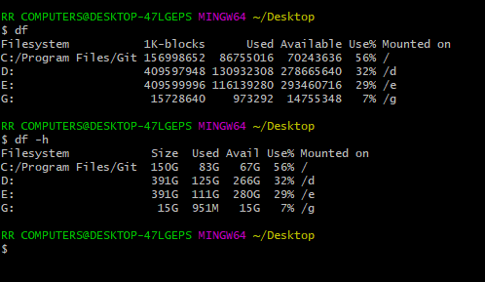

/ is the root directory.

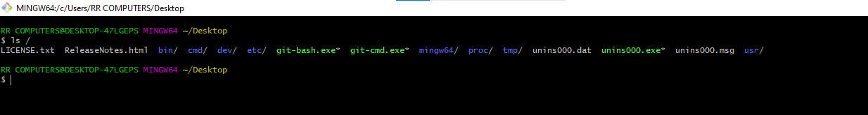

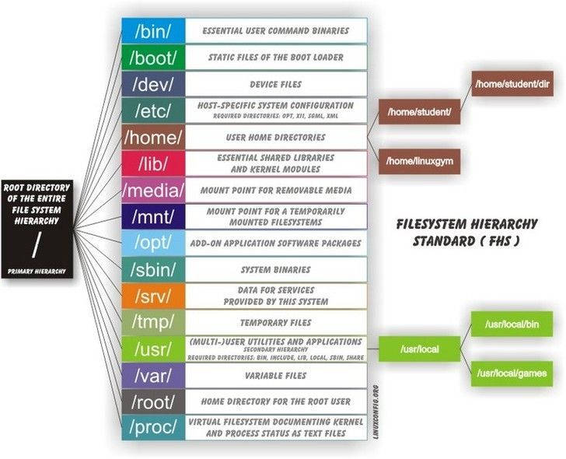

If we want to check the particular usage of each of the directories under root,we can use

$ du /bin -h

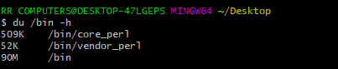

# Namespaces in Linux

On linux, we can create achieve the isolation using namespaces.

Let us say there is a hack, and he is able to get access to the one of the processes running in the linux system. If he has sufficent privilege it is possible that he can get access to all other process in the linux system.

And there by getting the access to all information on the linux system. We can solve this by using the resource isloation.

A namespace will create a completely isolated and protected environment for a process to run.

i.e when we run a process in a namesapace any operation performed by that process is only limited to that particular namespace and will not affect anyother process running on the system.

When we create a namespace we define the isolation, that we want interms of the filesystem, or pid number space or interprocess communication, Hostname or domain name or network interfaces/cgroups.

By default, processes will run on the root namespace.